

**LA GRANDEE INTERNATIONAL COLLEGE**

**Simalchaur, Pokhara Nepal**

AProject Proposal

On

**“Freelancing Platform”**

**Submitted to:**

Bachelor of Computer Application (BCA) Program

In partial fulfilment of the requirements for the degree of BCA under Pokhara University

**Submitted by:**

|  |  |  |  |
| --- | --- | --- | --- |
| **Name:** | **Course** | **Semester** | **P.U. Registration Number** |
| Anish Baniya | BCA | 6th | 2021-1-53-0347 |
| Sabin Gurung | BCA | 6th | 2021-1-53-0352 |
| Suyan Thapa | BCA | 6th | 2021-1-53-0371 |

**Date: 30/09/2024**

Table of Contents

Table of Figures iii

Abbreviations iv

1. Introduction 1
2. Background Study 2
3. Problem Statement 3
4. Objectives 4
5. Methodology 5
6. Project Gantt chart 6
7. Deliverables 7
8. Reference 8

# Table of Figures

Figure 5.1: Agile Model 5

Figure 6.1: Project Gantt Chart 6

# Abbreviations

# Introduction

A Freelance Marketplace System is an innovative web-based platform designed specifically to connect the freelancers with businesses seeking specialized services. The marketplace aims to create dynamic online environment where freelancers can showcase their skills and offer services, while clients can browse, and easily find the right professionals for their projects according their needs. This system streamlines the process of hiring the freelancers and enables efficient management of service-based tasks.

The FMS is being developed with the aim of creating a unified platform where freelancers from various fields such as design, development, writing, digital marketing and many more can advertise their services to a global audience. Clients, ranging from small businesses to large enterprises, can search for the appropriate skill sets, request services, and manage project timelines within the platform. By offering various service categories, the system allows clients to filter through relevant freelancers based on ratings, reviews, pricing, and expertise.

 The Freelance Marketplace project serves as a vital tool to create a vibrant online ecosystem where talent meets opportunity. By bridging the gap between talent and demand, it not only supports individual careers but also contribute to the growth of the freelance economy as a whole.

# Problem Statement

In the context of our country, there are no sufficient online platforms that particularly focuses on micro-jobs. Majority of the available online job platforms recruits individual for mainstream/career jobs such as teaching, banking etc. Most of the Nepalese freelancers prefer to work on global online marketplace for freelance services such as Fiverr, Upwork, etc. due to unavailability of such reliable gig marketplace. Most of the online freelancing web app allows freelancers for bidding which creates a cut-throat competition among freelancers. (Bibek Ranabhat, 2023)

* Lack of Nepali Payment Gateways (Khalti, Esewa)
* Limited local Freelance Marketplaces

# Objectives

Freelance marketplaces are amongst the fastest-evolving platforms, encouraged technology, which have revolutionized the way business entities and freelancers meet. With the demand for digitized services and remote work on a continuous rise, the appropriate FMS will make the process much easier and smoother for both freelancers and clients alike. Accordingly, if one gets hold of an appropriate platform, they can then smoothly go about managing their outsourcing requirements, while freelancers are in a position to present their skills and acquire work with a whole lot of simplicity.

* To implement the reliable local payment gateways.

# Background Study

# Methodology

A methodology is a series of processes or phases, which helps you define which stage you are at the given period. A set of procedures or methods to develop software is known as software development methodology. Methodology shapes a structure of software thus it is important to precisely choose the required method to develop software. In Context of our project, we choose Waterfall Module to develop a project as it works well in small project. In this method, project activities are break into linear sequential phases, each phase depends upon the previous one.

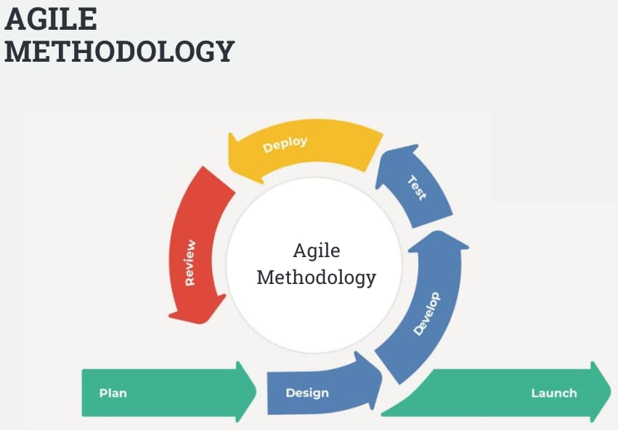

Figure 5.1: Agile Model

# Project Gantt chart

A Gantt chart is a popular project management tool used to visualize the schedule of a project. It displays tasks or activities against time, allowing project managers to track progress, manage dependencies, and allocate resources efficiently.

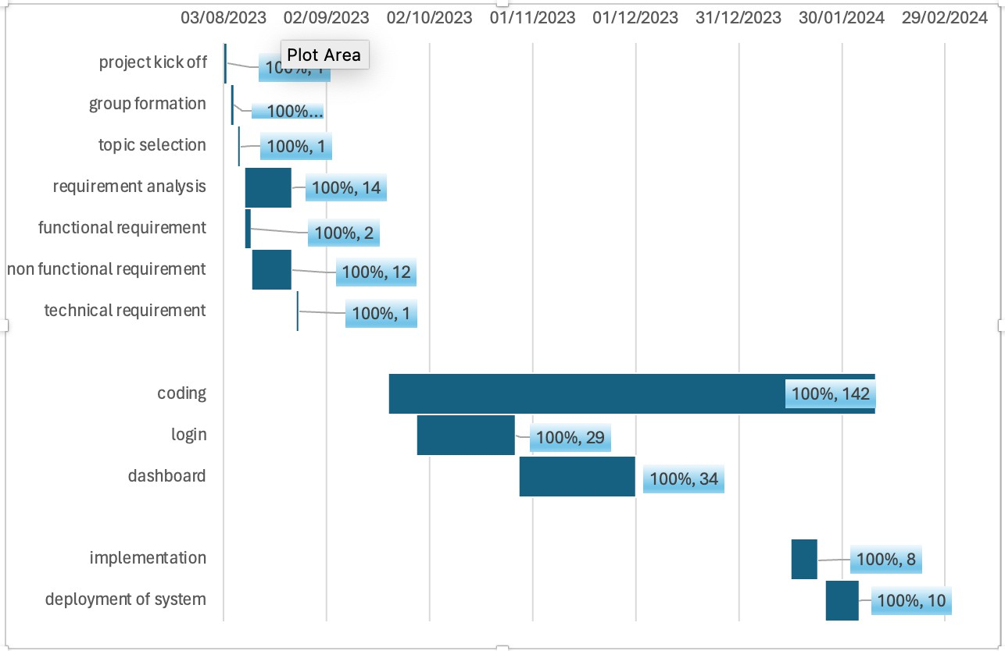

Figure 6.1: Project Gantt Chart

# Deliverables

* + **D1**: D1-description
  + **D2**: D2-description
  + **D3**: D3-description

# Reference Bibliography

xyz